**Nomination for Class of 1980 Secretary**

**Joe Grace**

**State you understand the list of 6 Class Officers Duties as outlined in the Class of 1980 By-Laws.**

The Secretary Shall:

1. Keep a record and publish the minutes of all Class and Council meetings.

2. Maintain all appropriate historical records of the Class other than those required by the

Treasurer.

3. Serve as Corresponding Secretary for the Council.

4. Provide the USNAAA with regular content to be published in “Shipmate” or other forums.

5. Coordinate with Company Representatives, maintain a current Class Registry that includes

deceased classmates and family members as appropriate.

6. Work with the Council to ensure that assistance to Classmates in need takes place.

7. Be responsible for any committees assigned by the President or Council.

I have been the Class Secretary for almost 30 Years. I understand the role and the responsibilities that come with the position very well.

**Why do you want to be the 1980 Class Secretary?**

It has been a privilege to serve in this role for many years. During that time I have worked to bring the Class together, encourage participation and support those in need. I have never missed a Shipmate Column during my tenure and have a wonderful working relationship with the Alumni Association, the Class Officers and the Academy. I was going to step down from the position with the departure of Tim Kobosko, and was asked personally to consider staying on in the position by the newly elected Vice President, Treasurer and many many Classmates who reached out to me directly. I believe that I am very committed to the role and keeping the Class together. It would be an honor to continue to serve.

**What is your vision for your 5-year term as Class Secretary?**

I believe that as the Class ages there will be an even greater need to keep everyone together on the same page and connected. This role has been the cornerstone of my tenure as Class Secretary and I have often been called the "glue" that has keep the Class together. If that is true, then continuing to do so would be a great honor. I believe that as a Class, we will have more individuals with more time available in retirement to support and get engaged with the Class. We will need to be supportive of illness, depression, loss, death, financial issues and so many more life experiences that come with aging. I believe that supporting those who raised their hands in T Court so many years ago is a solemn oath that we took together. I believe that this is a role that I have done to the best of my ability and will continue to do so if re-elected to the position of Class Secretary. If not, I will continue to support the Class and mentor my replacement in every way. I believe in this Class!

S

**Nominations for Class of 1980 Secretary**

**Joe Grace submitted by Janie Mines,** [jlmines@aol.com](mailto:jlmines@aol.com), 1-803-984-3796

**State you understand the list of 6 Class Officers Duties as outlined in the Class of 1980 By-Laws.**

Understood

**Why do you want to be the 1980 Class Secretary?**

Nominating Joe Grace

**What is your vision for your 5-year term as Class Secretary?**

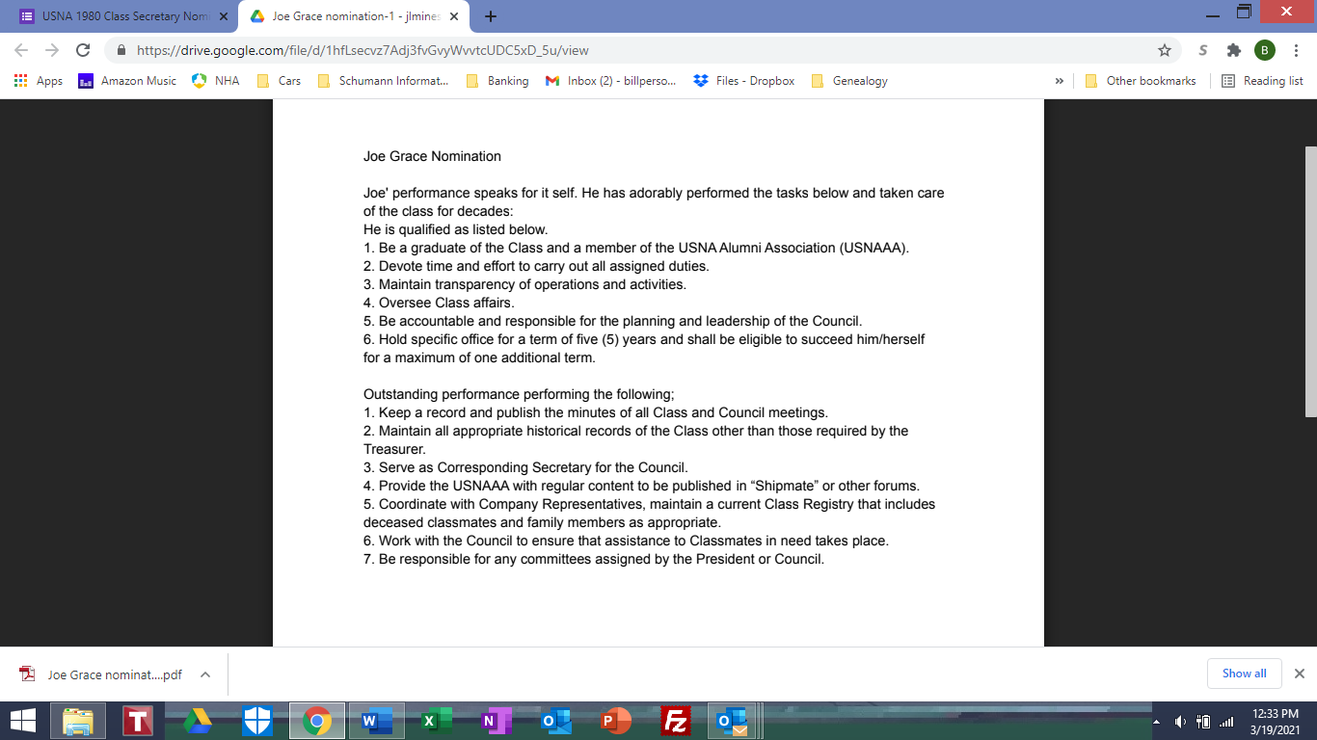Joe's continued service in accordance with bylaws and strategic plan